# Problem 1

a = input("Enter sequence of comma separated numbers : ")

lst = []

lst = a

print(lst)

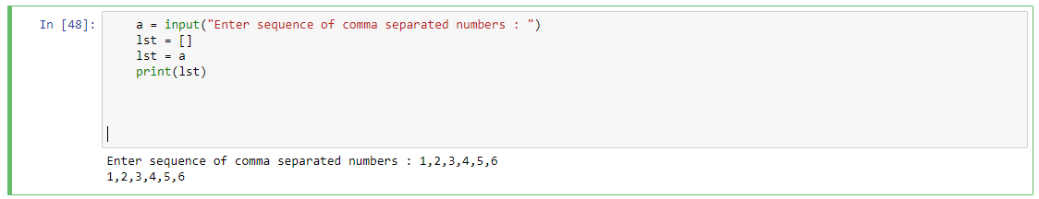

# Problem 2

for i in range(1,6):

for j in range(1,i+1):

print ("*", end="")

print('\n')

for i in range(4,0,-1):

for j in range(i,0,-1):

print("*", end = "")

print('\n')

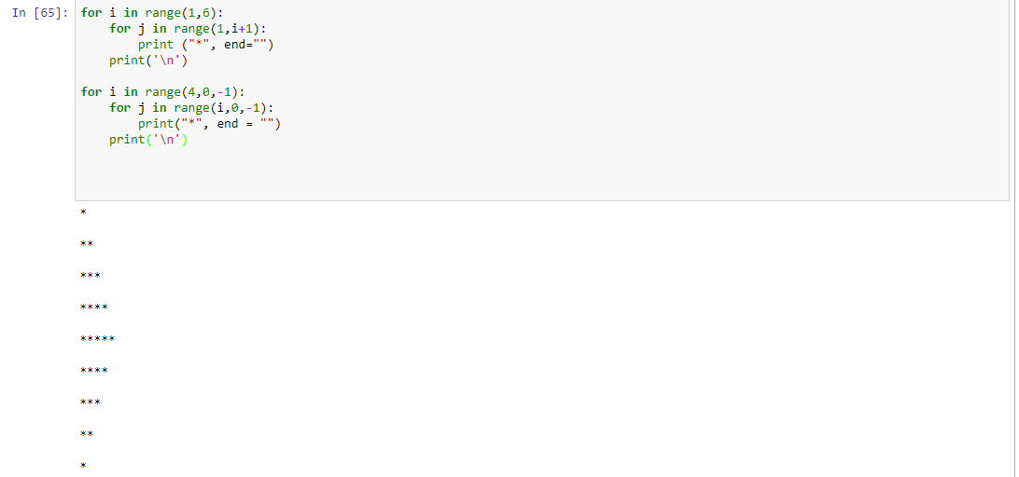

# Problem 3

a = input ("Enter a word : ")

print (a[::-1])

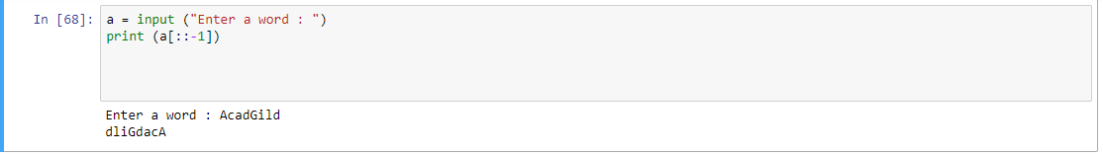

# Problem 4

print("WE, THE PEOPLE OF INDIA,", "\n" ,

" having solemnly resolved to constitute India into a SOVEREIGN,!" , "\n",

" SOCIALIST, SECULAR, DEMOCRATIC REPUBLIC " ,"\n",

" and to secure to all its citizens")

